In Search of the Lost Minoan Palaces

Samaritaki Georgia AM 3840 Project | Hy 252 -Object Oriented Programming|

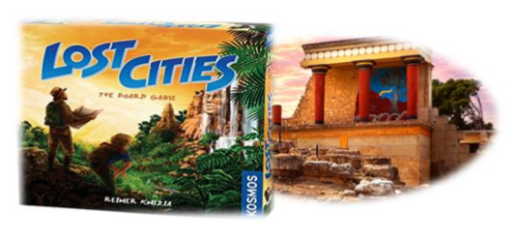

**Planning**

The implementation of the work will be based on the MVC model ( Model View Controller ).

Thus, our goal is for the Controller to be the connecting link between Model and view . So next

of our report we will break down the Model and Controller parts that are important

for this phase and finally we will refer a little to the view .

**Phase B**

The changes made in the second phase of the project were mainly in the Controller and View parts related to graphics and digital design. Some small cuts have also been made to the model but these mainly consist of deleting entire redundant functions. The changes have the ! .

Contents

**Model Package**  2

Enum Palace  2

Abstract Card Class and subclasses  2

* NumberedCard *(extends Card* )  2
* Abstract Class SpecialCard *(extends Card)*  3
* CardUML  3

Interface Finding  4

* Enum RareFinding *(implements Finding)*  4
* Enum Fresco *(implements Finding)*  4
* Class SnakeGoddess  4
* FindingUML  4

Abstract Class Pawn  5

* PawnUML  5
* Class Theseus *(extends Pawn)*  5
* Class Archeologist *(extends Pawn)*  5

Abstract class Position  6

* Class FindingPosition  6
* Class SimplePosition  6
* UMLPosition+Path  6

Class Path  7

Class Deck  7

Class Player  8

Class Board  8

**Model Controller**  9

Class Controller  9

**Model View**  10

Class View *extends JFrame*  10

**UML**  11

## Model Package

**Enum Palace**

It consists of the 4 Minoan palaces in the game

*K nossos, Malia , Phaistos, Zakros* enumeration values

and is used by almost all other hells.

*Methods* :

public String toString ( ); //Overridden method to String

returns the String name of the Palace

! public String getDescription ( ); // Accessor returns a short description of each palace

**Abstract Card Class and subclasses**

*Attributes* :

* Palace palace ; //common characteristic of all cards - The palace they belong to
* Private String image;

*Methods* :

|  |  |
| --- | --- |
| public Palace getPalace ( ); | Accessor  Returns the palace this card belongs in |
| ! public int getValue ( )  (removed from subclasses added here) | Returns the value number of each card  Ariadne has 11 and minotaur has 12 |
| public abstract String to String( ); | Accessor(overridden)  Returns the name of the card |
| getImage ( ) | Methods for graphics |

* **NumberedCard ( extends Card)**

Cards with numeric value 1-10 20 for each palace

*Attributes:*

* private final int value; //The value of the numbered card

*Methods:*

|  |  |
| --- | --- |
| public boolean matchCard( Card c); | Observer  Returns true if the card is equal or more than the last card played |
| public String toString ( ) | Returns String  “ Numbered Card of value” with value of card |

* **Abstract Class SpecialCard ( extends Card)**

SpecialCard consists of its two subclasses Ariadne and Minotaur

* **Minotaur ( extends SpecialCard )**

*Methods:*

|  |  |
| --- | --- |
| public boolean matchCard( Card c ) | Observer  Checks if Card c can be played over minotaur |
| public String toString ( ) | Accessor  Returns “Minotaur Card” with card's palace |

* **Ariadne ( extends SpecialCard )**

*Methods:*

|  |  |
| --- | --- |
| public boolean matchCard( Card c ) | Observer  Returns true because Ariadne can be played over all the cards |
| public String toString () | Accessor  Returns “Ariadne Card” with card's palace |

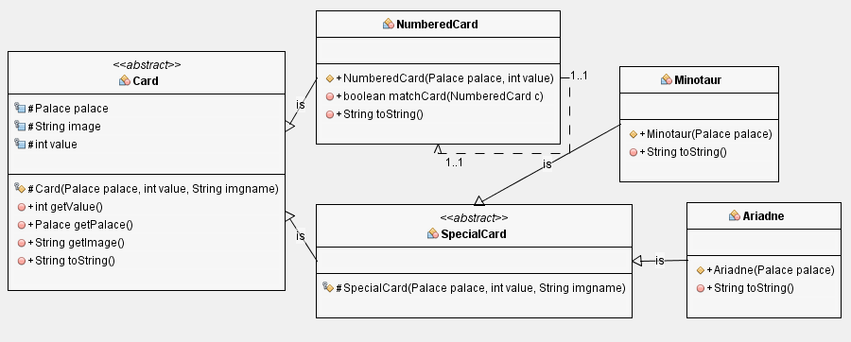**CardUML**

**Interface Finding**

Acts as a connection between subclasses:

fresco, RareFinding , SnakeGoddess

*Methods:* public String getImage ( ); //Methods for graphic environment

public String getDescription ( );

* **Enum RareFinding ( implements Finding)**

Consists of the 4 rare findings as Finding(value)

DiskOfFaistos ( 35), RingOfMinoa (25), JewelOfMalia (25), RhytonOfZakros (25);

*Attributes:*

* final private int value; //value of the finding

*Methods:* All methods inherited plus

|  |  |
| --- | --- |
| public String toString ( ) | Accessor  Returns the name of the enum |
| ! public String getValue ( ) | Returns the points value of the enum |

* **Enum Fresco ( implements Finding** *)*

Consists of the 6 frescos according to the strg image given

Fresco1(20 ), fresco2(20), fresco3(15), fresco4(20), fresco5(15), fresco6(15);

*Attributes:*

* final private int value; //value of the finding
* String image;

*Methods:* All methods inherited plus

|  |  |
| --- | --- |
| public String toString ( ) | Accessor  Returns the name of the enum |
| public int getValue ( ) | Accessor  Returns the value of the rare finding |

* **Class SnakeGoddess**

*Method:* All Methods inherited

**FindingUML**

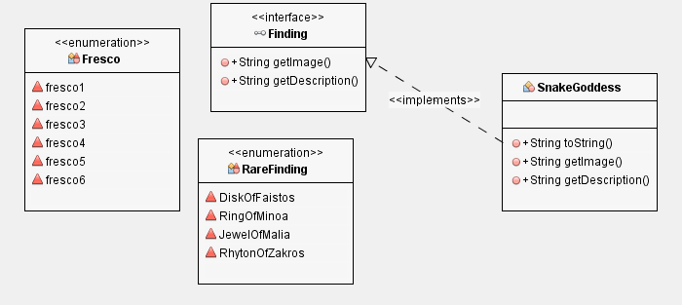

**Abstract Class Pawn**

***PawnUML***

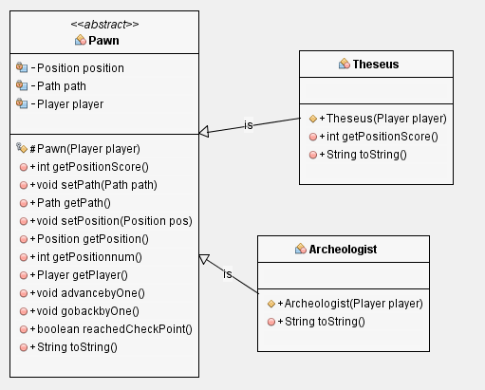*Attributes:*

* private Position position ;

//the position the pawn is on

* private Path path ;

//the path the pawn is on

* private final Player player ;

//the owner of the piece

*Methods:*

|  |  |
| --- | --- |
| public int getPositionScore ( ) | Accessor  Returns the points of the position the pawn is on |
| public void setPath ( Path path) | Transformer  Sets the path the pawn is on to path |
| public Path getPath ( ) | Accessor  Returns the path the pawn is on |
| public void setPosition ( Position pos ) | Transformer  Sets the pawns position to pos |
| ! public int getPositionnum (); | Accessor  Returns the number position the pawn is in the path |
| public Position getPosition ( ) | Accessor  Returns the position of the pawn |
| public Player getPlayer ( ) | Accessor  Returns the owner of the pawn |
| public void advancebyOne ( ) | Transformer  Advances pawn by one in the path providing that its not in the last place |
| public void gobackbyOne ( ) | Transformer  Returns pawn one place back providing its not in the last place |
| public boolean reachedCheckPoint ( ) | Observer  Returns true if the pawn has passed position 7 of the path providing it has begun a path |
| Public abstract String toString ( ); | Overridden method  Returns the name of the pawn |

* **Class Theseus ( extends Pawn)**

*Methods: All inherited plus:*

|  |  |
| --- | --- |
| public int getPositionScore ( ) | Accessor  Returns the position score doubled  ( theseus earns double the value of the position) |

* **Class Archeologist ( extends Pawn)**

**Abstract class Position**

*Attributes:*

* private final int points;
* private final int posnumber ; //position number in path
* private final Path path ;
* ! protected boolean hasFinding ; // updated by each class

*Methods:*

|  |  |
| --- | --- |
| public int getPoints ( ) | Accessor  Returns the points specified in this position  Using posnumber ( in path) |
| ! public int getNum () | Accessor  Returns the posnumber |
| ! public int getPoints (); | Accessor  Return the points specified in this position |
| ! public boolean hasFinding (); | Observer  Returns true if the position has been found else false |
| public Path getPath ( ) | Accessor  Returns Path the path the position belongs to |

* **Class FindingPosition**

*Attributes:*

* Finding finding ? // the finding buried in this position

*Methods:*

|  |  |
| --- | --- |
| public Finding getFinding ( ) | Accessor  Returns finding in the current position  And sets hasFinding boolean to false |
| public void setFinding ( Finding finding) | Transformer  Puts the finding in this position and sets hasFinding boolean to true |

* **Class SimplePosition**

*!* Sets the hasFinding boolean to fals *e*

**UMLPosition+Path**

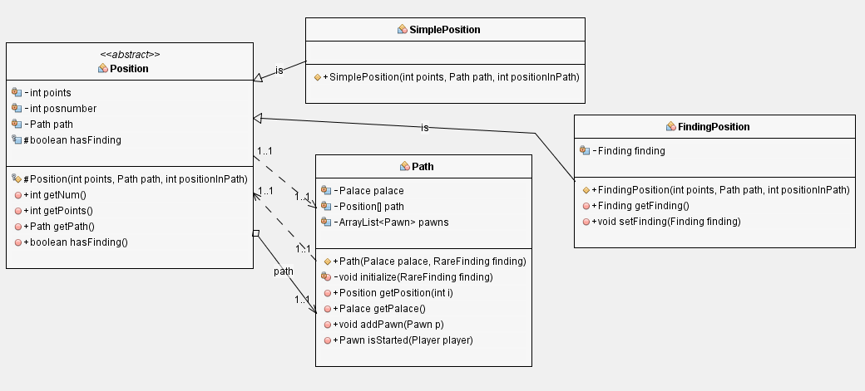

**Class Path**

*Attributes:*

* private final Palace palace ;
* private final Position []path = new Position[9];
* private ArrayList <Pawn> pawns;

*Methods:*

|  |  |
| --- | --- |
| private void initialize( RareFinding finding) | Transformer  Sets position 2,4,6,8,9 to special and rest to simple Adds rare finding randomly to one of FindingPositions |
| public Position getPosition ( int i ) | Accessor  Returns the i th position of the path |
| ! public Palace getPalace () | Accessor  Returns the enum value of the palace of path |
| public void addPawn ( Pawn p ) | Transformer  Adds pawn to path |
| public boolean isStarted ( Player player ) | Observer  Returns true if the player has placed a pawn on this path false |

**Class Deck**

*Attributes:*

* private final ArrayList <Card> deck;

*Methods:*

|  |  |
| --- | --- |
| private void initialize( ) | Transformer  Initializes all cards of deck |
| ~~public ArrayList getDeck ( )~~ | ~~Accessor~~  ~~Returns the array list with the deck~~ |
| ~~public void shuffleDeck ( )~~ | ~~Transformer~~  ~~Shuffles cards of deck~~ |
| public Card drawCard ( ) | Accessor && Transformer  Draws card from deck removes it and returns it |
| public boolean isEmpty ( ) | Observer  Returns true if there are no more available cards |
| public int availableCards ( ) | Accessor  Returns the number of available cards in deck |

**Class Player**

*Attributes:*

* private final Cardhand [ ];
* private final NumberedCardT LastPlayed [ ];
* private ArrayList <Finding> Syllogi ;
* private ArrayList <Finding> Fresco;
* private final Pawn pawns[ ];
* private int Score;
* private int NumOfStatues ;

*Methods:*

|  |  |
| --- | --- |
| public Card[ ] getCards () | Accessor  Returns an array with the available cards of the player |
| ~~public void discardCard ( Card c )~~  ! public void ReplaceCard ( int index, Card c) | Transformer  Replaces card c in hand on index position |
| public Card getLastCard ( Palace palace) | Accessor  Returns the last card played on the specified palace |
| public void AddCard ( Card C ) | Transformer  Precondition: Player does not have 8 cards on hand  Postcondition: Adds card c to palyers hand |
| ! public void updateLastCard ( NumberedCard add ) | Transformer  Changed the last card of same palace in lastCard array |
| public void takeFinding ( FindingPosition pos ) | Transformer  Postcondition : Checks the type of the finding in position and adds it accordingly to player |
| ! public int getScore () | Accessor  Calculates the sum of pawn's positions rare findings values, statues, frescos values and updates Scores  Returns score |
| ! public int statuesCollected () | Accessor  Returns the int value of the sumOfStatues |

**Class Board**

*Attributes:*

* private final Path paths[ ] = new Path[4];

*Methods:*

|  |  |
| --- | --- |
| private void distributeFindings ( ) | Transformer  Creates all frescos and statues and distributes them randomly |
| ! public Path getPath (Palace palace) | Transformer  Returns the path of the specified palace |

## Model Controller

**Class Controller**

*Attributes:*

* private final Player player1, player2;
* private final Board board ;
* private final Deck deck ;
* View view ;
* private boolean phaseB, turn ;

*Methods:*

|  |  |
| --- | --- |
| public void init ( ) | Transformer  Initializes views and listeners |
| private void init_player_cards ( ) | Transformer  initializes players cards in the beginning |
| public Player getTurn ( ) | Observer  Returns the player who plays |
| public void endTurn ( ) | Transformer  Switches turn |
| public boolean isFinished ( ) | Observer  Returns True if 4 checkpoints have been reached or the deck has been emptied |
| public String getWinner ( ) | Accessor  PreCondition : The game has ended  Postcondition Returns the winner comparing the two scores |
| private void setListeners ( ) | Transformer  Connects buttons with listeners |
| public int checkPointsReached ( ) | Accessor  Calculates from the player's pawns how many checkpoints have been reached |
| public void availableMoves ( Player player, Position pos ) | Transformer  Updates player class and view of the item in position |
| public Pawn choosePawn ( Pawn playerPawn []) | Transformer  Displays a popup dialog that allows the player to choose a pawn |
| public void updateView ( ) | Transformer  Postcondition updates the information displayed on the screen |

*Listeners:*

|  |  |
| --- | --- |
| private class CardListener implements MouseListener | Card listener |
| private class DeckListener implements MouseListener | Deck button listener |
| private class ButtonListener implements MouseListener | Fresco buttons |

## Model View

The view constitutes all the graphics part of the game . It consists of a gentleman JFrame which _ has 3 Jpanels ( pane 1, pane 2, mainpane ) one for each player and a main one that has the board with the paths . Each player 's cards form buttons for the game and after chooses (or discards ) a card Conventionally I chose to have a clue valid movement to make it gray as I pass to the second phase of each round .

That view uses also a JExtension which _ constitutes subclass of JLayeredPane and pronounces the capability addition background image ? _

**Class View extends JFrame**

*Attributes:*

* JLayeredPane pane1, pane2, mainpane ;
* JButton deck, F1, F2, Cards1[] = new JButton [ 8], Cards2[] = new JButton [8];//8 for each
* JLabel Info, availablePawns1, player1 LastCard[ ], player2LastCard[],

availablePawns2, Score1, Score2, Statues1, Statues2;

* JLabel path1[], path2[], path3[], path4[], pathPoints [ ];
* JLabel RareFinding1[], RareFinding2[], Frescos1[], Frescos2[];
* JLabel statue1, statue2, statuetxt1, statuetxt2;
* JFrame frescoswindow1, frescoswindow2;
* Map<Pawn, JLabel > pawns = new HashMap < >( 9 );
* private final ClassLoader cldr ;

*Methods: Apart from getter classes*

|  |  |
| --- | --- |
| private void initComponents ( )  ~and other init ... methods | Transformer  Initializes buttons and labels |
| public void updateLastCardPile ( Boolean player, Card c) | Transformer  Updates Last card of player |
| public void updateRareItem ( Boolean player, RareFinding finding) | Updates rare items of player ~ “ ungrays ” the image of rare item |
| public void updateFresco ( Boolean player, Fresco finding) | Updates the window with the frescos of  Player with the new fresco |
| public void updatePawn ( Pawn pawn) | Transformer  Updates the position of pawn ~ moves the JLabel in path |
| public void updateBoardInfo (..)  public void updatePlayerInfo ( … ) | Transformer  Update info on screen |
| public void replaceCard ( JButton but, Card c) | Transformer  Replaces the image in JButton but of that of card c |
| public void grayCard ( JButton but, Card c) | Transformer  Sets image of card c grayed in JButton but |
| public Image grayImage ( Image img ) | Transformer  Returns the grayed version of img |
| public void toggleWindow ( Boolean player ) | Transformer  Toggles visibility of fresco window of player |
| public void showMessage ( String title, String message, int messageType ) | Brings up an information-message dialog titled "title". |

## Project UML

End